**TEAM NAME: SEMANTICS**

**TEAM LEADER: G S NITHYASHREE**

**EMAIL ID:** [**nithyashr99@gmail.com**](mailto:nithyashr99@gmail.com)

**PROBLEM STATEMENT: CRISIS COMMUNICATION**

**SOLUTION BRIEF OVERVIEW**

Crisis Communication, is currently the highest targeted situation prevailing in the entire world today. The reason as we know being the COVID-19 pandemic. In such times, the public is at its most vulnerable stage in terms social life, economy, well-being, professional and personal affairs. Thus, highest measures not only terms of the infected patients have been taken but also for the public whose health is at risk is being carefully looked into by the government. Media plays the major role in the world at this point by helping the public get maximum information regarding the situation and keeping them updated at all times. Media includes, News and Infotainment Broadcasts, Social Media (WhatsApp, Facebook, Twitter, Instagram etc.), Google Search Engine, YouTube and the Newspapers. The IT sector has been working ever since the lockdowns were announced. They addressed issues through various media platforms in order to help the public.

Our project has been developed to attend to this prevailing crisis situation in the southern region of our country, India. It has been started on a smaller scale initially to record the experience of a part of the public and eventually extend to further regions. The ideology behind this was to provide the public not only with documented information but also to provide them with personal one to one conference sessions with budding counsellors of our country. To provide them with practical knowledge and emotional support. The whole project was built on the basis of a web application using Python Flask. This web application acts as a user interface for both the counsellor (mentor) and public (mentees). The user can opt to be a part of a virtual meeting and get help from the mentor at a scheduled hour or opt to read about the same on the website that is being updated from time to time.

The public requires constant updates and validation during such situations from the media as well as the government. And for the abundance in population makes the government always addresses them as a whole. Therefore, the IT has come up with various technologies that helps the public get a personalized service that would help them get answers for most of their queries. And that has been the aim of this project as well which is to adhere to maximum requests from the public.

**SOLUTION DESCRIPTION**

The problem being addressed in this this project is Crisis Communication. As discussed earlier, in the time of crisis the government may not be able to attend to every individuals’ problems and thus it leads to public disturbance and no clarity in how the situation is going to be handled. By using technology most of the public issues have been adhered to and reduced to its maximum extent.

The basis of the project is a web application. A web application as we know is an application stored on a remote server and delivered over the internet through a browser interface along with web services (also known as, web apps)- to ease the use of this application. The whole web application has been developed using Python Flask. Flask is a micro web framework that helps build web applications easily because it does not require particular tools or libraries. The web application integrates with a database in the backend part of it which is handled using MySQL. The frontend acts as a user interface for both the general public and the mentors. These mentors will be qualified and certified counsellors of the region. When a person registers on the web application, they will have an option to either book an appoint to engage in a one to one interactive session with a counsellor or read about the updates on the website. Once the person registers either as a mentee or mentor, their information gets stored in a database. After registration, the mentor must provide a schedule of their availability time to address public queries and the mentee upon selecting the option of ‘Book an Appoint’ will immediately receive a Zoom meeting link with a mentor available at that hour.

In a situation that calls for public to remain in social distancing norms, face recession in the economy and most importantly ensure they are being precautious at all steps most of the public tends to face stress, anxiety and agitation to ward everything happening. Information from the media does not provide full satisfaction and thus affects most of the elderly, people in low living conditions and business economists. Our project extends to the southern regions of India to help every individual cope informatively, emotionally and sensibly towards the prevailing COVID 19 situation and also reduce the burden on the hospital staff and government staff who have been working extremely hard to get control over the situation.

**SOLUTION ARCHITECTURE**

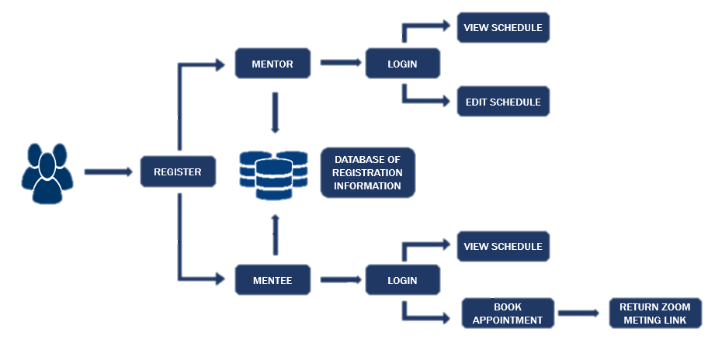

**EXPLANATION**

The architecture depicts the flow of control that is being implemented in this project. Initially, prior to registration the user interface for the general public (mentees) and the certified counsellors (mentors) will be the same. Once the person registers either as a mentor or mentee, the information associated with that particular individual will be recorded in the database. Upon, login for the mentor the visible options will be ‘View Schedule’ and ‘Edit Schedule’. The mentor can add their availability details and upload the Zoom meeting link that is accessible by the registered mentees. For the mentees, on logging in there are two options to look through existing schedules in ‘View Schedule’ option and/or ‘Book Appointment’, to attend a new session. To attend the same the mentee will receive a Zoom meeting link at that particular hour. This project on the whole focuses on one to one interaction with qualified counsellors of Southern India, to reduce stress and anxiety in public during the COVID 19 crisis.

**IBM CLOUD SERVICES/SYSTEMS**

We have created a python app covid19semantics using IBM cloud foundry services.  
 And we have made use of this service Continuous Delivery-1l. After enabling this service, we have a tool chain with which you can automate builds, tests, deployments and more.